BOLT Marketing Website Installation Instructions

**August 20th 2012**

Table of Contents

Overview 3

Document Purpose 3

Preparations 3

Instruction of Delivered files 3

3



 4

 4

 4

Installation &Configuration 4

Install IIS7.5 under Windows7 4

Install &Configure MySQL Server5.5 5

Restore MySQL database. 5

Install and configure PHP and WordPress 6

Configure PHP 6

Configure WordPress 10

Instruction of Website Files 11

“bolt\wp-config.php“ 11

“bolt\sitemap.xml” and “bolt\sitemap.xml.gz” 12

“bolt\wp-admin” and “bolt\wp-includes” 12

“bolt\wp-content\upgrade” “bolt\wp-content\uploads” and “bolt\wp-content\index.php” 12

“bolt\wp-content\plugins” 13

“bolt\wp-content\themes\bolt” 13

header 14

footer 15

sidebar 15

Content 15

How to Edit Page &Post 18

Editor 18

Edit panel 19

Edit Page 20

Edit Post 21

Edit News 22

Plugins 23

All in One SEO 23

Google Analytics for WordPress 23

Google XML Sitemaps 24

Yet Another Related Posts 25

Akismet 26

Update 26

Database backup file 26

Php and bolt 26

Instruction file 26

About States Map 27

About Page Templates 28

# Overview

## Document Purpose

This document will introduce the deployment of BOLT Marketing Website.

## Preparations

1. Make sure that the disk you intend to install has enough space.

2. Softwares need to install:

▶IIS7 or above

▶MySQL Server5.5 or above

▶PHP 5.4 or above

# Instruction of Delivered files

## 



BOLT Marketing Website using WordPress

## 

PHP program

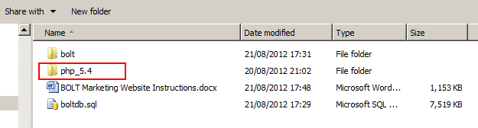

You can install PHP using a new one, but we have changed some configuration of PHP in order to let the website execute properly.

## 

Instruction document

The information in the document:

* The way to install the website;
* The explanation of files we delivered;
* The way to edit the pages and the posts in the website in the document;

## 

Database backup file.

The information in the file:

* The backup data as the type of SQL script;

You should create a database named “wordpress_db” before you import the data.

# Installation &Configuration

## Install IIS7.5 under Windows7

If you have not installed IIS, you should install it first.

If your IIS does not have URL Rewrite module, you must install it first. You can Install URL Rewrite module using the following link:

http://www.microsoft.com/web/gallery/install.aspx?appid=urlrewrite2

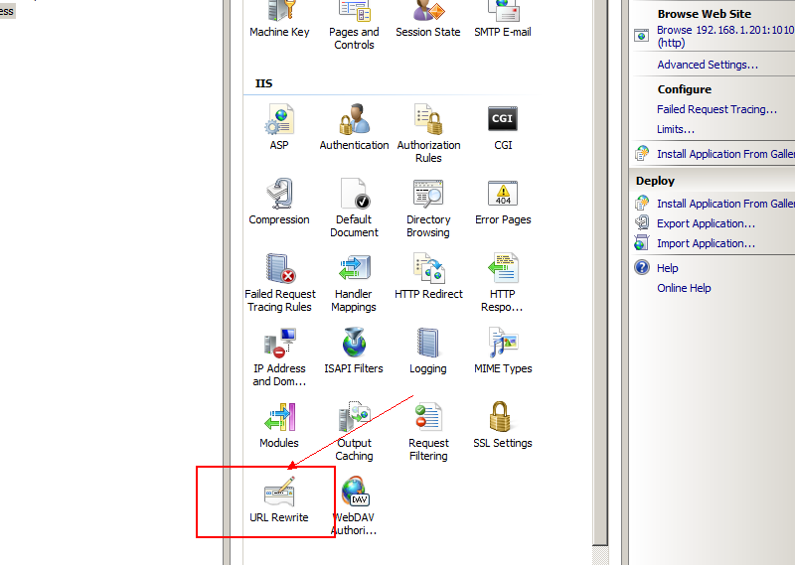

## Install &Configure MySQL Server5.5

If you have not installed MySQL, install MySQL Server 5.5 or above.

## Restore MySQL database.

The database backup data is in the file of “boltdb.sql”.

You can restore the data use the command as following:

1. Create database wordpress_db using MySQL Commend Client:

mysql> CREATE DATABASE `wordpress_db` DEFAULT CHARACTER SET utf8 COLLATE utf8_general_ci;

1. Restore the data from file boltdb.sql using Windows Command:

shell> mysql -uroot -p1qaz@WSX wordpress_db < c:\boltdb.sql

## Install and configure PHP and WordPress

There are two folders as “php_5.4.5” and “bolt” in the “bolt.rar” file. Extract the two folders to your install directory, for example, “D:\Program Files”.

### Configure PHP

1. Open the file “php.ini” in the folder of “php_5.4.5”. Find the text of “date.timezone = PRC” and change the time zone information according to your nation.

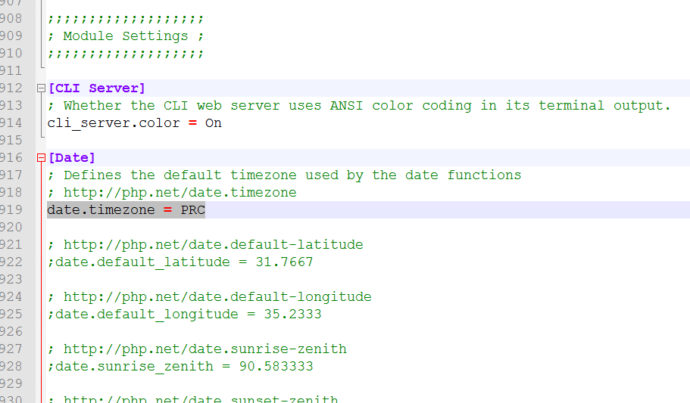

1. Open the IIS and then open Handler Mappings to install PHP function of IIS.

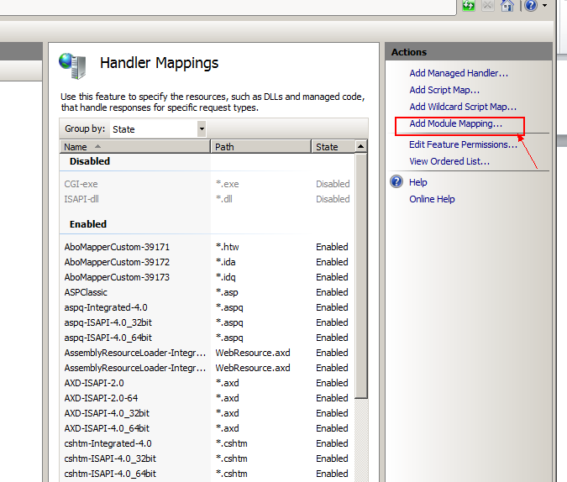

1. Open “Add Module Mapping” and configure it as following. (If your computer do not has FastCGI module, enable it or install it)

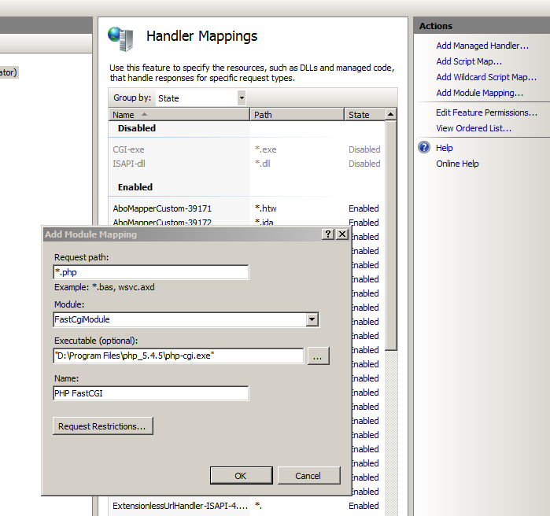

1. Add PHP default document. Open Default Document module in IIS and configure as following.

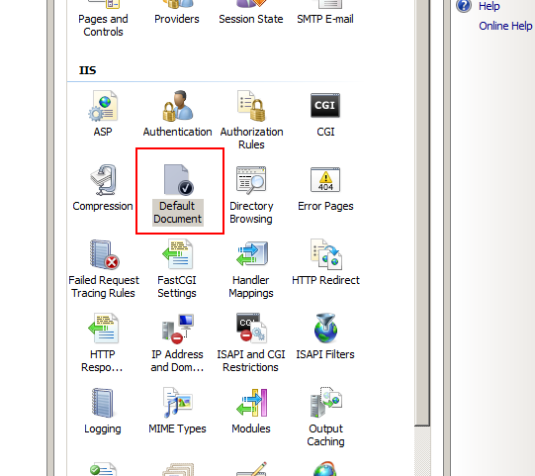

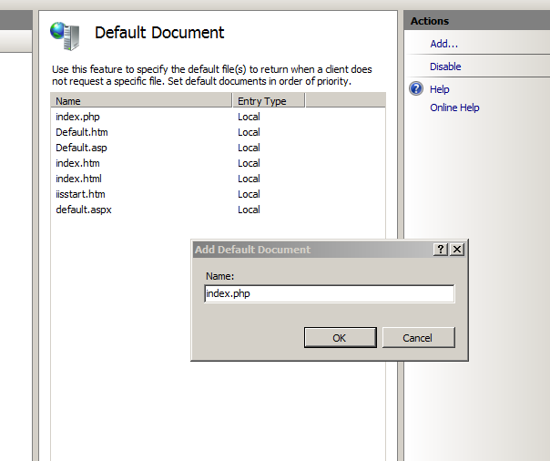

### Configure WordPress

1. Add a Website which point to the folder of “bolt” in the IIS. (Note: The IP must be “127.0.0.1” and the port must be “10101” or I don’t confirm it is properly).

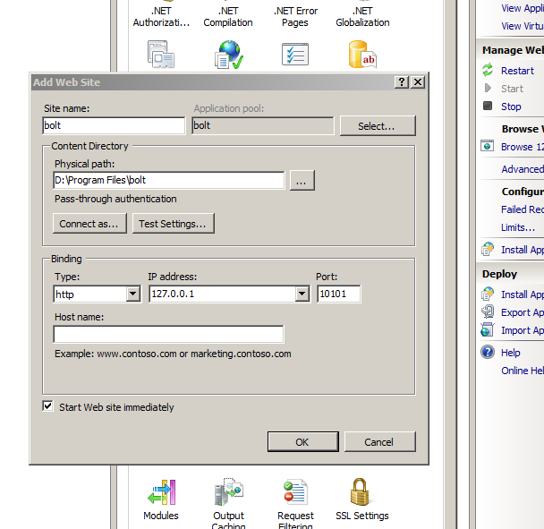

1. Configure the website in the “wp-config.php” which in the “bolt” folder as following:

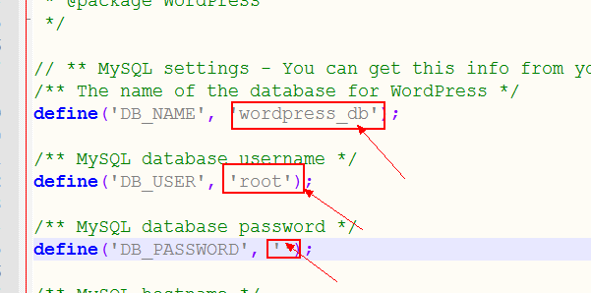

Now you can browse the website as “http://127.0.0.1:10101/”;

# Instruction of Website Files

## “bolt\wp-config.php“

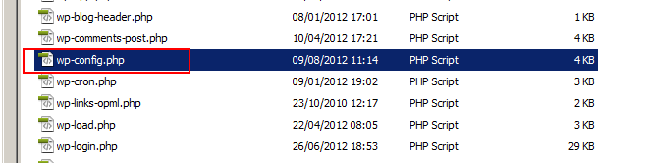

The information of the file:

* The configuration information of WordPress;

## “bolt\sitemap.xml” and “bolt\sitemap.xml.gz”

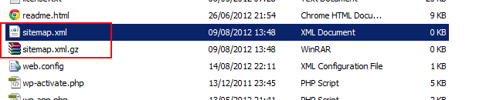

The information of the files:

* The sitemap files used by Google XML Sitemaps plugin;

## “bolt\wp-admin” and “bolt\wp-includes”

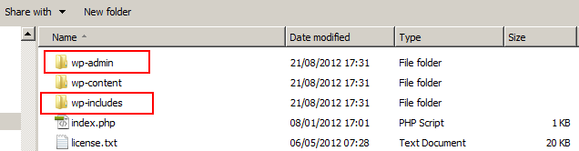

The information of these folders:

* The program folders used by WordPress ;

## “bolt\wp-content\upgrade” “bolt\wp-content\uploads” and “bolt\wp-content\index.php”

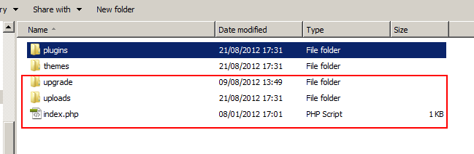

The information of these folders and files:

* We do not use them now;

## “bolt\wp-content\plugins”

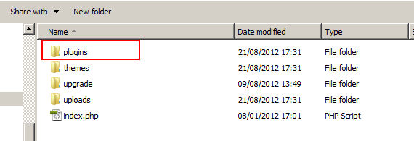

The information of these folders and files:

* All the plugins we installed are in this folder;

## “bolt\wp-content\themes\bolt”

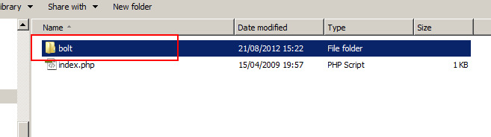

The information of the folders:

* All the website files are in this folder;

Each pages of the website contain four parts 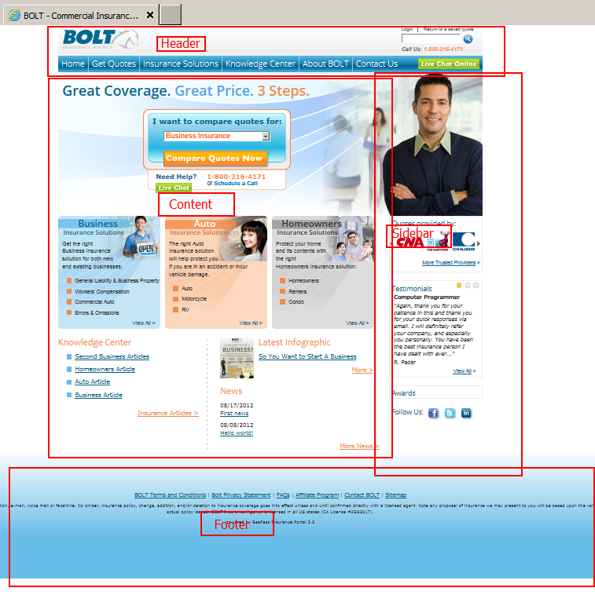

### header

The header content is included in the file of “header.php”:

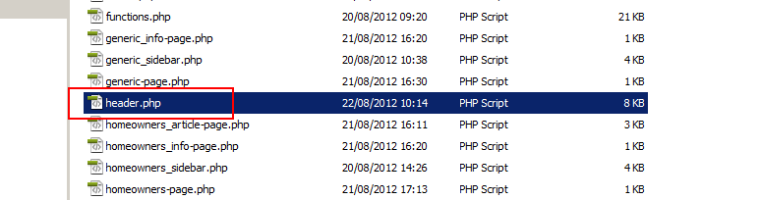

### footer

The footer content is included in the file of “footer.php”:

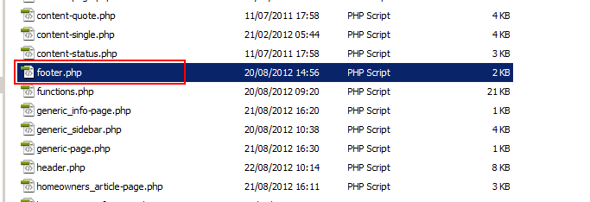

### sidebar

The sidebar content is included in five files because there are five kinds of sidebar:

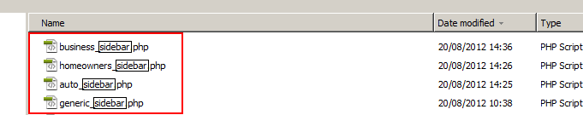

And

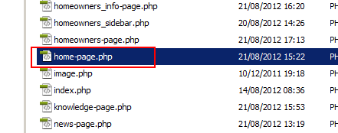

### Content

There are five kinds of content part: business pages, auto pages, homeowners pages, generic pages, and other pages. I will explain all of the five kinds.

#### Business pages:

There are three business page templates:

* Business-page.php: A Page Template that display main pages about business insurance; for example the “Business Insurance” page.
* Business_article-page.php: A Page Template that display articles list about business insurance;
* Business_info-page.php: A Page Template that display sub-pages about business insurance; 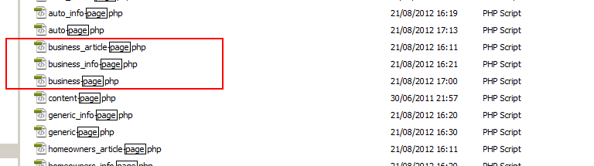

#### Auto pages:

There are three auto page templates:

* Auto-page.php: A Page Template that display main pages about auto insurance; for example the “Auto Insurance” page.
* Auto_article-page.php: A Page Template that display articles list about auto insurance;
* Auto_info-page.php: A Page Template that display sub-pages about auto insurance;

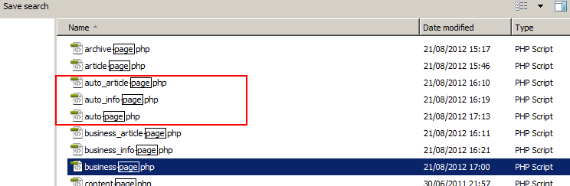

#### Homeowners pages:

There are three homeowners page templates:

* Homeowners-page.php: A Page Template that display main pages about homeowners insurance; for example the “Homeowners Insurance” page.
* Homeowners_article-page.php: A Page Template that display articles list about homeowners insurance;
* Homeowners_info-page.php: A Page Template that display sub-pages about homeowners insurance;

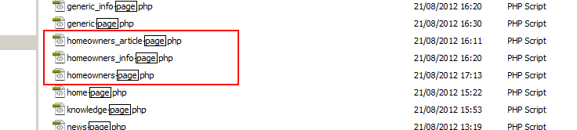

#### Generic pages:

There are two generic page templates:

* Generic-page.php: A Page Template that display main pages about generic information; for example the “About BOLT” page.
* Generic_info-page.php: A Page Template that display sub-pages about generic information;

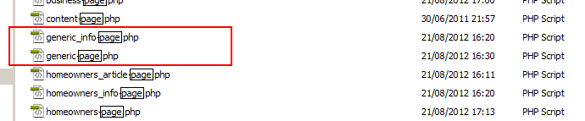

#### Other pages:

There are six page templates here:

* Archive-page.php: A Page Template that display articles archive;
* Article-page.php: A Page Template that display articles list;
* Home-page.php: A Page Template that display home page;
* Knowledge-page.php: A Page Template that display “Knowledge Center”;
* News-page.php: A Page Template that display news list;
* Search-page.php: A Page Template that display searching result;

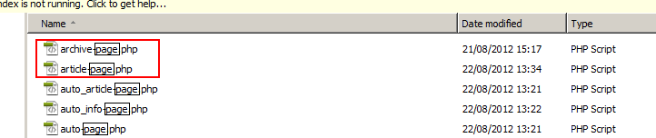

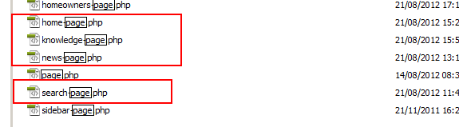

# How to Edit Page &Post

If you want to edit the content of pages on website, you should enter the following URL:

<http://127.0.0.1:10101/wp-admin/>

Use admin account to login. The user name is “admin” and the password is “123”.

## Editor

WordPress provide two editors: Visual Editor and HTML Editor (If you can’t see Visual Editor, you may not enable it. You can enable it following the next paragraph.).

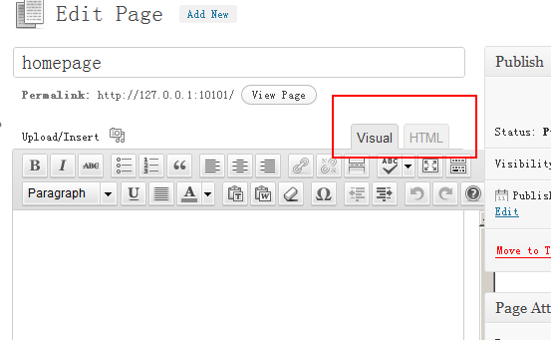

You can enable or disable visual editor in Your Profile menu.

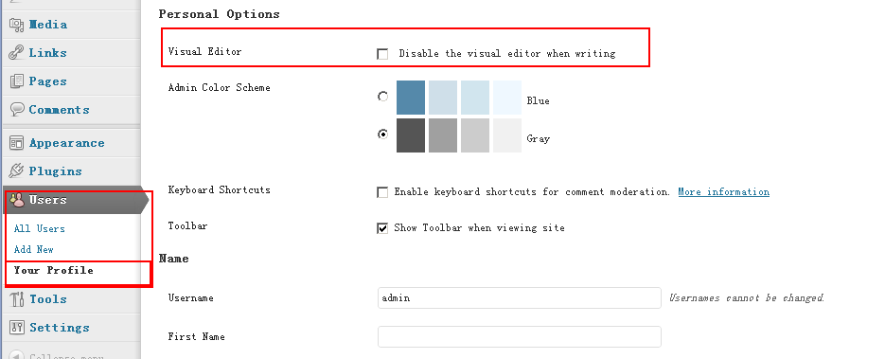

If it is acceptable, it is advisable to use HTML Editor. If it can’t be accepted, you can use Visual Editor. However, you can’t use Visual Editor to edit the content which you can’t create through Visual Editor.

## Edit panel

Go to one of the page in the website. For example, the page of “<http://127.0.0.1:10101/business-insurance/solutions/>”:

Then you can see Edit Page or Edit Post link on the upper left corner of every web page (If you can’t see it, you may not login at first):

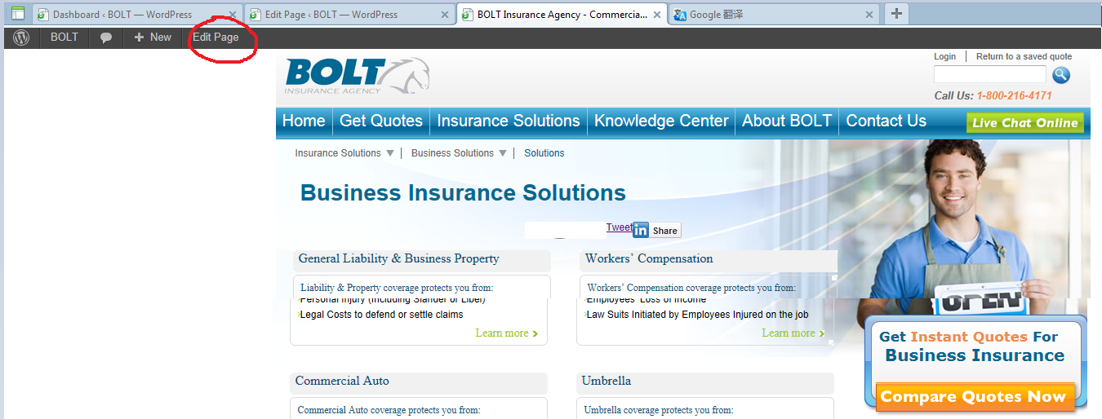

The page of “<http://127.0.0.1:10101/business-insurance/articles/second-business-articles/>”:

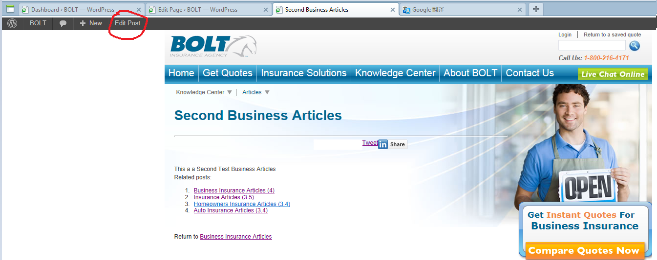

## Edit Page

Use page: /business-insurance/solutions/umbrella-insurance as an example:

1. Enter this page, click Edit Page link to enter its editor.

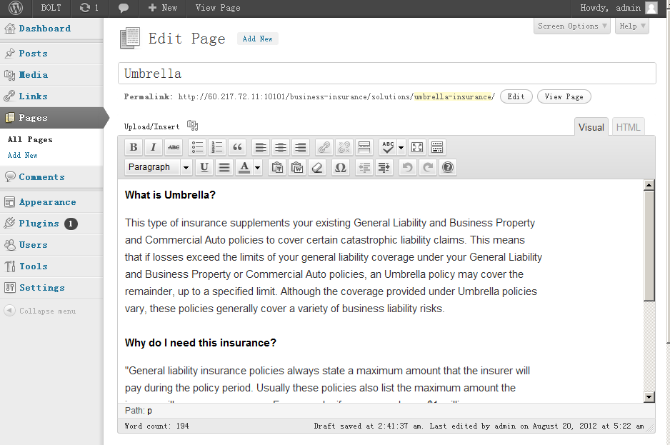

2. You can edit the content of the page in Visual Editor or HTML Editor.

3. You can publish page state unnder “Publish” tab:

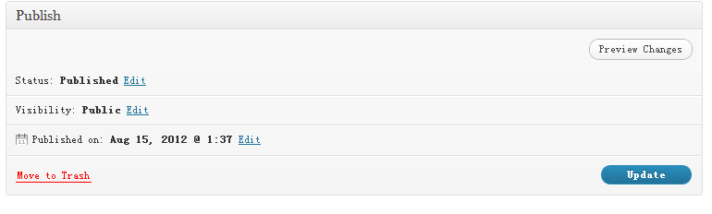

4. You can set page attributes and template under “Page Attributes” tab:

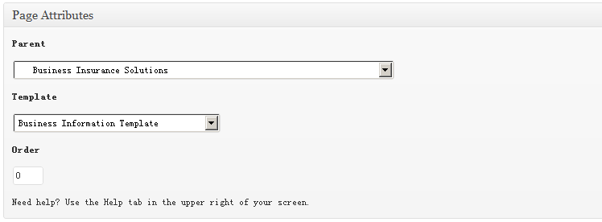

## Edit Post

Use page: /articles/business_article/business-article/ as an example:

1. Enter this page, click Edit Post link to enter its editor.

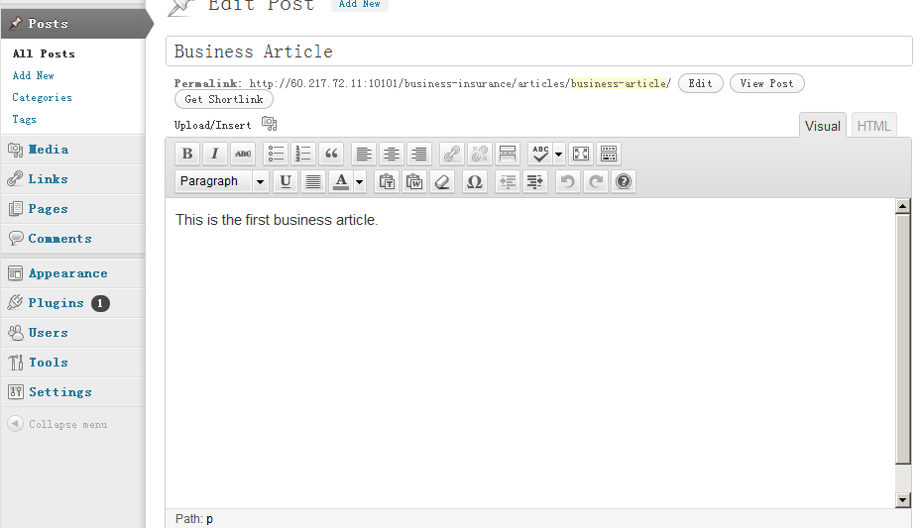

2. You can edit the content of the page in Visual Editor or HTML Editor.

3. You can set page state under “Publish” tab:

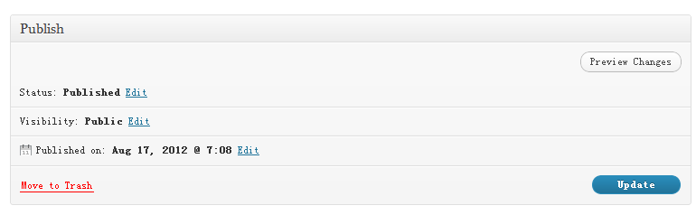

5. You can set article category under “Categories” tab:

NOTE: If you want add business insurance articles, you should choose the “articles” category under “business-insurance” category. Adding homeowners insurance articles and auto insurance articles is the same.

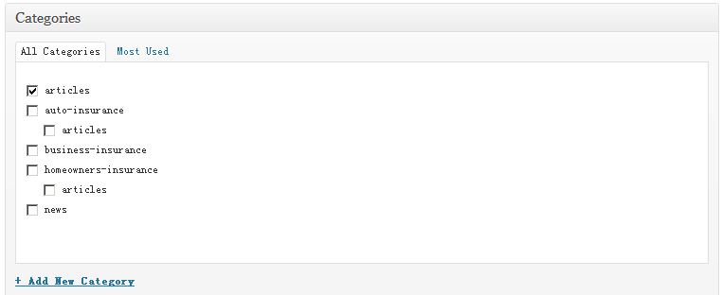

## Edit News

It is same as Edit Articles. You should choose “news” category under “Categories” tab to add news:

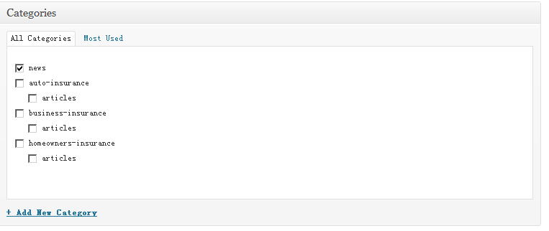

# Plugins

There are five plugins in the website:

* All in One SEO Pack <http://wordpress.org/extend/plugins/all-in-one-seo-pack/>
* Google Analytics for WordPress <http://wordpress.org/extend/plugins/google-analytics-for-wordpress/>
* Google XML Sitemaps <http://wordpress.org/extend/plugins/google-sitemap-generator/>
* Yet Another Related Posts Plugin <http://wordpress.org/extend/plugins/yet-another-related-posts-plugin/>
* Akismet <http://akismet.com/>

I only introduce the state of these plugins in our website. If you want to know these plugin deeply, you must look for more description of them.

## All in One SEO

We only use it to add titles and descriptions of all the pages. And you can add titles and descriptions of your post when you add new articles and news.

## Google Analytics for WordPress

We input our Google Analytics account in the website so that we can test the plugin. If you want to use it, you must have your own Google Analytics account and input your UA code in the Settings tab of the plugin:

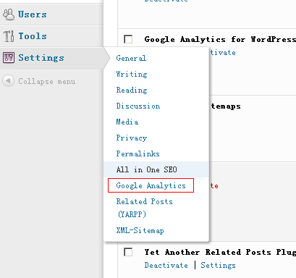

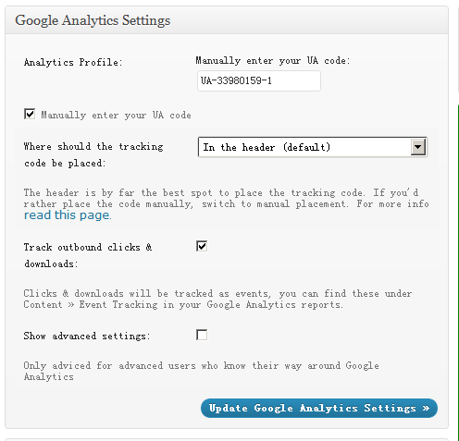

You can set other plugins’ configuration at the same menu.

## Google XML Sitemaps

I add two files of “sitemap.xml” and “sitemap.xml.gz” in the “bolt” folder. I grant everyone permission to the two file. I have built the sitemap according the website, but I think you like to rebuild it when the website is online actually.

You can click “rebuild the sitemap” to rebuild it.

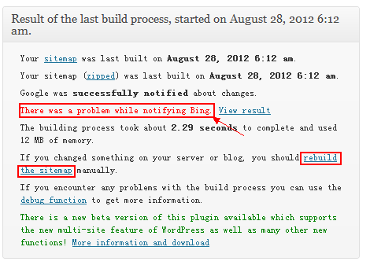

There is an error message, but it actually is wrong information. If you click “View result” following, you can be sure to it.

## Yet Another Related Posts

I only activate the plugin. You can see the plugin work below the article:

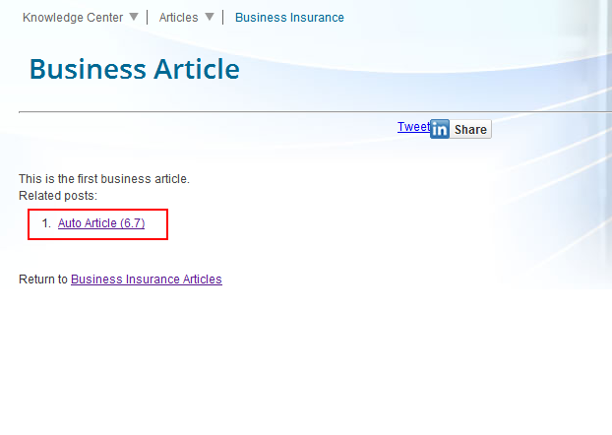

The number “6.7” following the article name is the match ratio. You can set match threshold at the settings tab:

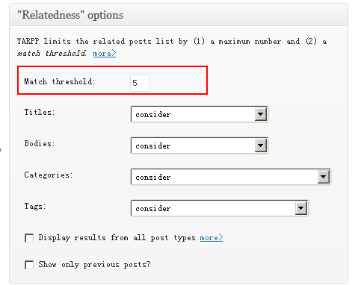

## Akismet

We even don’t activate the plugin.

# Update

There are two files and two folders in the file I give you. Even if I send all of the files or folders to you, I may only change some of them. You only need to update the files or folders I changed. I can only give you the information of which folder I have change, but I can’t give you the more detail information (We do not have version control now).

## Database backup file

If you changed the data in the database, import the backup file will clear what you have changed and I have not good method to avoid it.

## Php and bolt

If you have not changed the files of the two folders, you can simply replace them except the configuration files (php.ini, wp-config.php). If you have changed the files of two folders, A VCS(such as svn) is helpful.

## Instruction file

You can see or not see the file.

# About States Map

The map can work but it has some trick.

The links can only be absolute URL in the map. For example, the URL of Wanshington is <http://www.boltinsurance.com/washington-business-insurance>. We write the URL when we create the map. When the page navigate to the link, it redirect to the link of <http://www.boltinsurance.com>. When you click states in the map and HMTL below the map, you will navigate to <http://www.boltinsurance.com>. It is the reason.

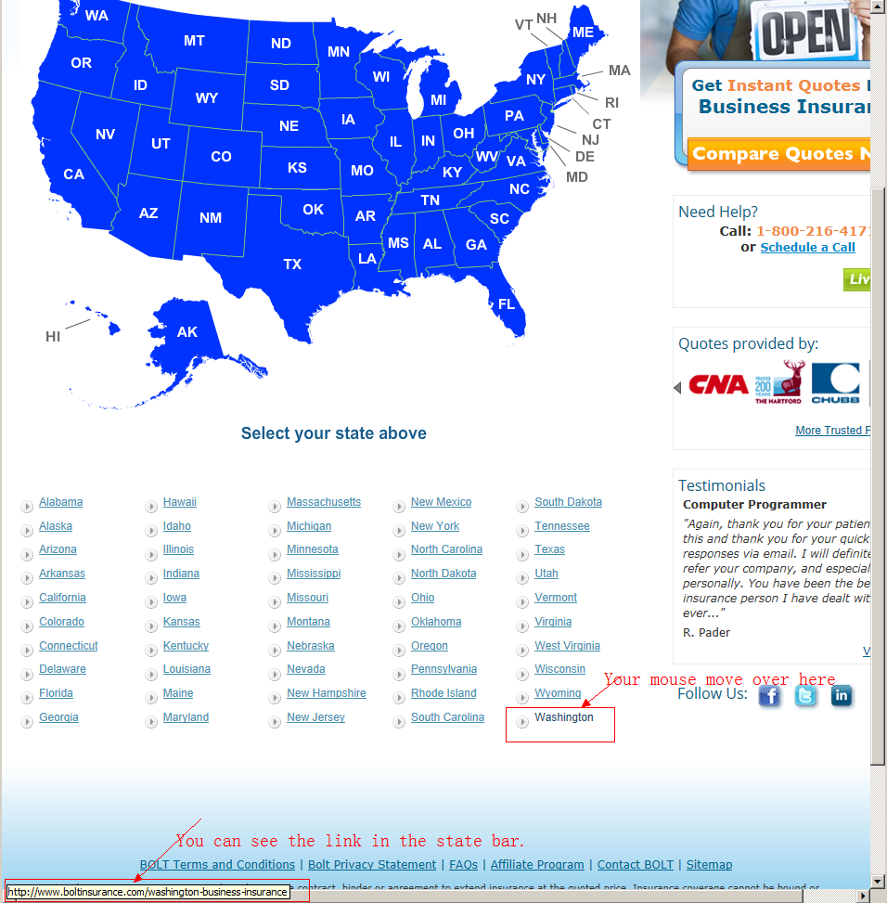

By the way, we can change the links of the HTML below the map, but we can’t change the links of map.

# About Page Templates

**Business/Auto/Homeowners/Generic Information Template** and **Business/Auto/Homeowners/Generic Template** are the templates used to create pages about Auto/Home/Business/Generic. The difference between information template and template is little. You can read the instruction about auto insurance template for more information.

**Default Template:** The WordPress Page Template and we do not use it now;

**Articles Archive Template:** The page display articles archive;



**Articles Template:** The page displays all the articles. We do not use it now;

**Auto Information Template:** The page displays Auto Insurance information. For example, it is the template of the page of Auto Insurance. We use different templates for the homepage of Insurances (for example the page of Auto Insurance Solutions) and the pages below it (for example the page of Auto Insurance).

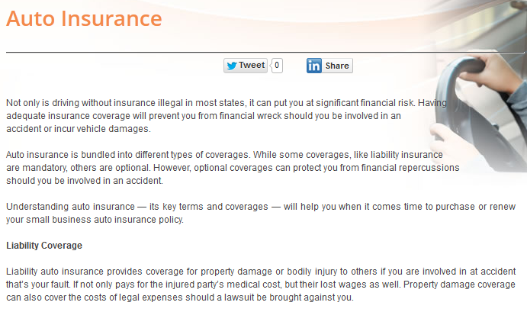

Dividing Line

**Auto Insurance Articles Template:** The page displays the auto insurance articles. And we do not have this kind of articles now.

**Auto Template:** The page display Auto Insurance Solutions. This template has small different with Auto Information Template, but we create two templates now. The main different between them is the dividing line.

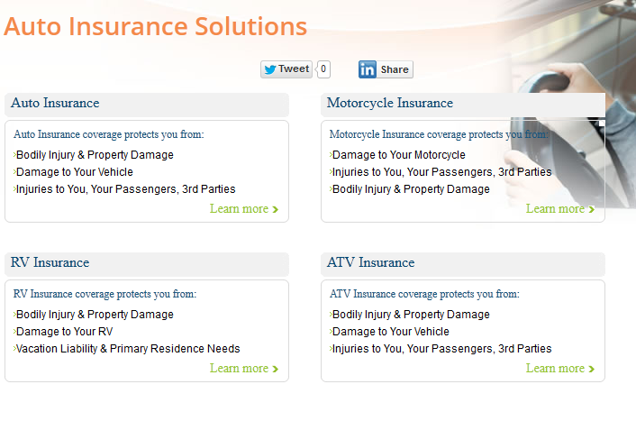

No Dividing Line

**Business Information Template:** The page displays Business Insurance information. For example, it is the template of the page of Commercial Auto.

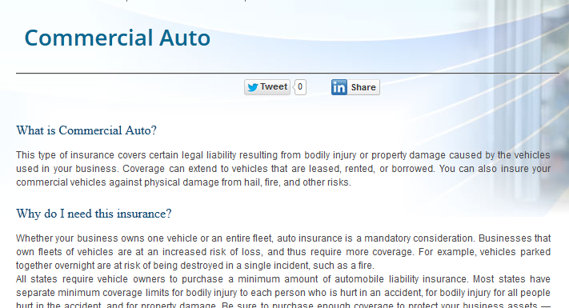

**Business Insurance Articles Template:** The page displays the business insurance articles.

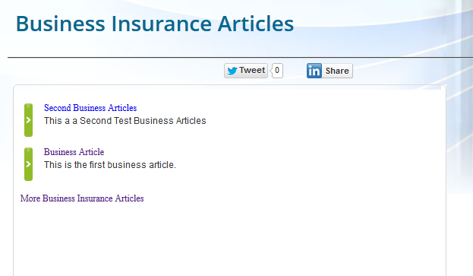

**Business Template:** The page display Business Insurance Solutions.

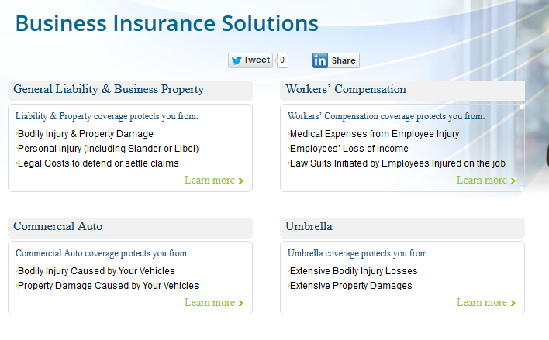

**Generic Information Template:** The pages display the generic information. The pages which need the dividing line use the template.



**Generic Template:** The page displays the generic information. Because the pages of generic do not have the dividing line, so we use the template.

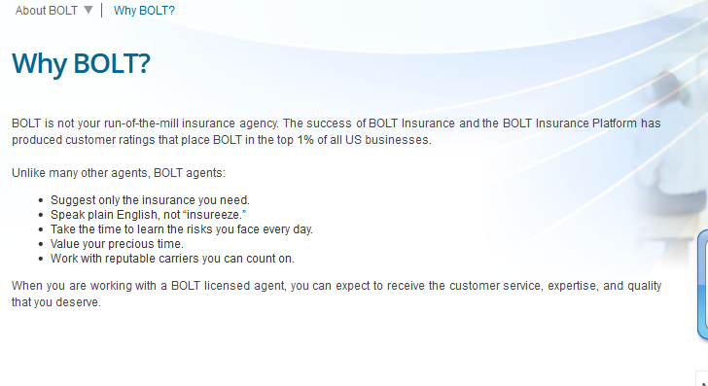

**HomePage Template:** The template display home page.

**Homeowners Information Template:** The page displays homeowners Insurance information. For example, it is the template of the page of homeowners Insurance.

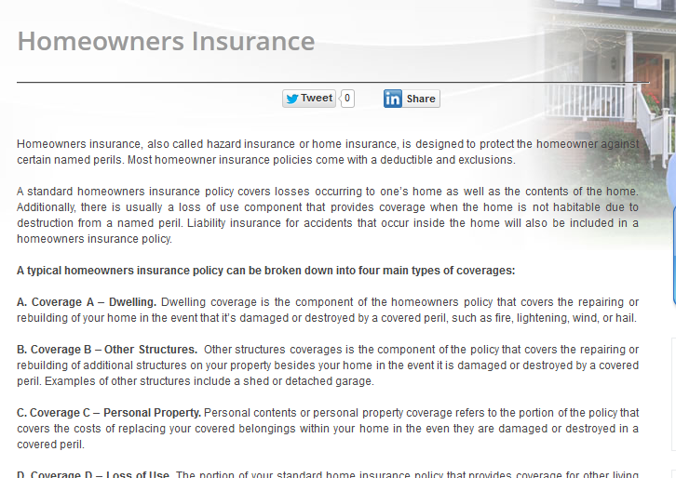

**Homeowners Insurance Articles Template:** The page displays the homeowners insurance articles. And we do not have this kind of articles now.

**Homeowners Template:** The page display Homeowners Insurance Solutions.

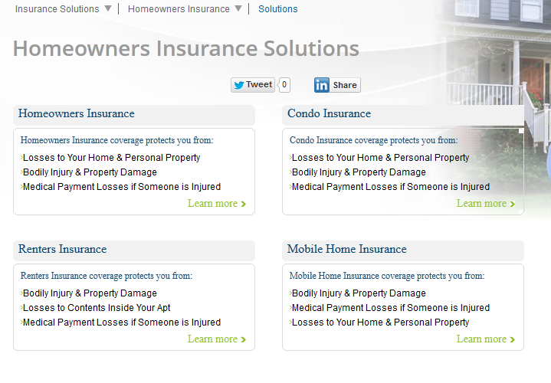

**Knowledge HomePage Template:** The template is only used for the page of Knowledge Center, because the articles part in the page display recently articles dynamically (include auto insurance and homeowners insurance if you add these kinds of articles).

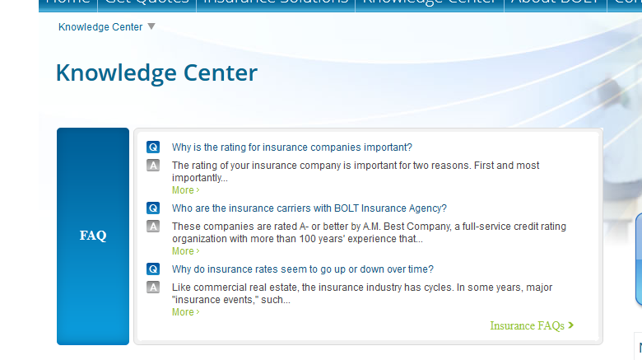

**News Template:** The page displays news.

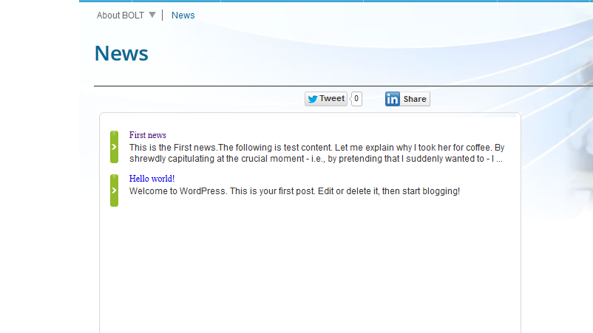

**Search Information Template:** The page display search result.

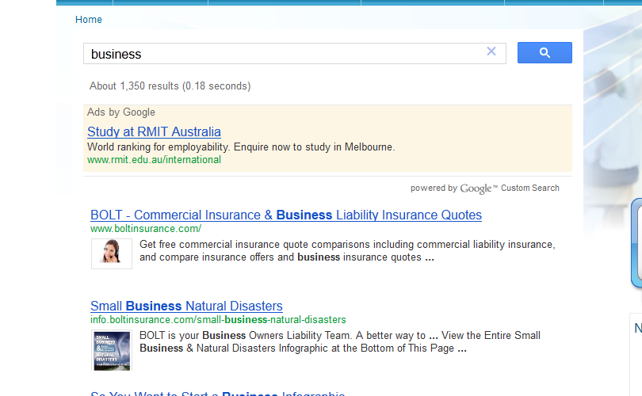

**Showcase Template and Sidebar Template:** The WordPress template and we do not use them now.